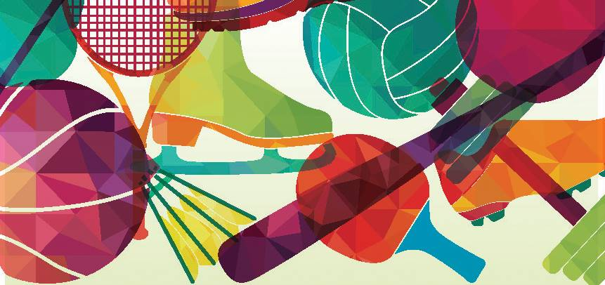

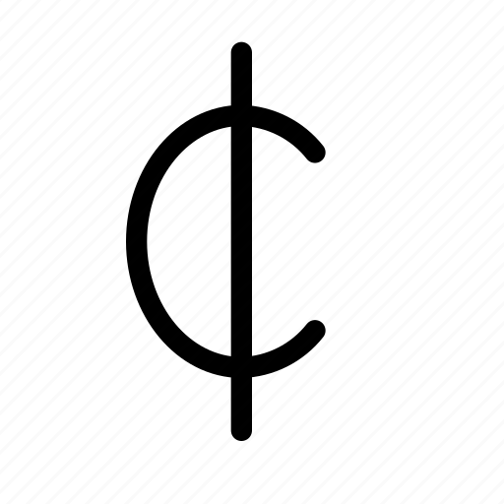

Name/Phone Number | $ Amount/Minute | $ Flat Amount | $ Total Due | Pd

Participant/Group Name: ___________________________________ Total Raised: _______________

My Church/School, City: ___________________________________________________________________

Make checks payable to the LCMS Northern Illinois District and include pledge form(s)

60 minutes @ 10 /min = $6.00 | 120 minutes @ 10 /min = $12.00 | 300 minutes @ 10 /min = $30.00
60 minutes @ 25 /min = $15.00 | 120 minutes @ 25 /min = $30.00 | 300 minutes @ 25 /min = $75.00
60 minutes @ 50 /min = $30.00 | 120 minutes @ 50 /min = $60.00 | 300 minutes @ 50 /min = $150.00
60 minutes @ $1.00/min = $60.00 | 120 minutes @ $1.00/min = $120.00 | 300 minutes @ $1.00/min = $300.00

The cost of some items that promote wellness in Belize:
Soccer Ball | $10.00 |  | 3 Sets of Cones | $30.00
Basketball | $20.00 |  | Volley Ball & Net | $50.00
Running Shoes | $25.00 |  | 2 Sets of Pinnies (practice vests) | $60.00

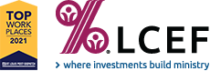*Participants – please send pledge form and all payments to:
Bringing It For Belize

Bringing It For Belize takes place the week of October 17-23, 2021
I/We will exercise for my/our wellness and for the wellness of people in Belize.
Donors, thank you in advance for your generous support. Money will be collected October 24-November 7, 2021
LCMS Northern Illinois District
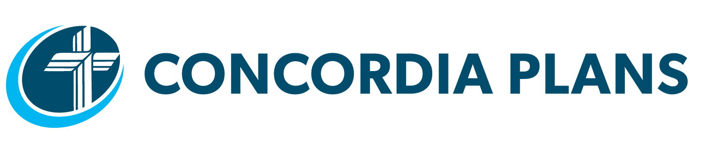 2301 S. Wolf Rd, Hillside IL 60162

